R1100S(R1150) by DIY

Fuel and ignition timing adjustment

2022/08/14

July 7, 2022

v0.7

Table of Contents

1. Introduction. 4

1.1. Target of this Document 4

1.2. What you can do with this document 4

1.3. Cost 4

1.4. Policies for describing this document 5

2. Assumptions for adjustment 6

2.1. Engine Adjustment Points 6

2.1.1. Lean Fuel Consumption by Emission Regulation 6

2.1.2. Individual Differences and Aging 6

2.1.3. Durability Margin for Commercial Vehicles 7

2.1.4. Aside: Advantages of Modern Motorcycles 7

2.2. RISK 7

2.3. Before Starting Adjustment 8

3. Stock ECU operation 9

3.1. Inputs and Outputs 9

3.2. Feedback Function 10

3.3. air-fuel ratio sensor specifications 11

3.4. Stock ECU Issues 11

3.5. Aftermarket Parts Issues 12

4. Understand the current status of the engine. 13

4.1. Tool 1: GS911 13

4.2. tool 2: innovate LC-2 14

4.3. Familiarize yourself with the data. 14

5. Adjustment of fuel 15

5.1. Air-fuel ratio adjustment by LC-2 15

5.1.1. Overview of Operation 15

5.1.2. Disadvantages 16

5.2. ECU chip replacement 17

5.2.1. Overview of Operation 17

5.2.2. Preparation 17

5.2.3. Chip Replacement Procedure 18

5.2.4. Disadvantages 18

5.3. ECU chip replacement + 02 sensor disconnection 19

5.3.1. Overview of Operation 19

5.3.2. Disadvantages 19

5.4. LC-2 + ECU chip replacement 20

5.4.1. Overview of Operation 20

5.4.2. Disadvantages 20

6. Ignition timing adjustment 21

6.1. Overview 21

6.2. Ignition timing change by ECU chip replacement 21

6.3. Ignition timing change by Hall sensor adjustment 21

6.4. Disadvantages 21

7. Confirmation of adjustment results 22

7.1. Overview 22

7.2. Checking the Fuel Condition 22

7.3. Ignition timing check 24

7.3.1. Hall sensor adjustment check 24

7.3.2. Checking ECU Adjustment 24

Appendix 25

Appendix 1 Installation of Innovate LC-2 25

Outline drawing 25

Reference program: Target set at 13.2 AFR 25

Appendix 2 Reference: Author's Adjustments 26

Normal mode 26

Sharp mode 26

Power mode 27

Appendix 3 Simple Horsepower Measuring Instrument 28

Appendix 4 Switching Maps with Coding Plugs 29

What is a Coding Plug? 29

Coding plug specifications 29

Map Switching by Coding Plug 30

Appendix 5 87c510 Adapter 31

Appendix 6 Contact Information for the Author 32

# Introduction.

This document summarizes how to change fuel and ignition timing using the stock ECU for the R1100S R1150.

This document is not intended for business, so it says some good things and some bad things.

In addition, since the authors are not experts, I hope that by publishing the results of our study and receiving feedback, I can further deepen our knowledge.

The document is accompanied by a PDF bookmark, or perhaps a Word table of contents, so that if you are viewing the document in a browser, you can download and view it to get to the desired item more quickly.

## Target of this document

I target people who If you have the money, the shortcut is to ride a modern motorcycle or consign it to a contractor.

* I would rather have fun on a current motorcycle (especially R1100S, R1150) than on the latest motorcycle
* I like DIY. I want to make my engine in good shape, even if it takes a lot of time and effort and a little risk.
* I want to adjust the operating characteristics of the engine.
* I'd rather see the data myself to verify the adjustments than to hear other people's reviews.
* Some understanding of the terminology in this document

## What you can do when you read this document

This document is intended to enable you to

* Measurement and adjustment of fuel injection (air-fuel ratio)
* Measurement and adjustment of ignition timing advance angle
* Little understanding of ECU engine control

**This document does not list the appropriate values for fuel or ignition timing**. The appropriate settings vary widely depending on individual motorcycle specifications and the quality of gasoline available.

The author's R1100S settings are shown in Appendix 2 for reference.

## cost

Implementing all of the tools described in this document will cost about $350 to $500.

Although it does not improve performance for the cost, it can provide accurate information on the condition of the motorcycle, such as breakdowns and aging, and help keep it in good shape over the long term.

It also reveals a significant portion of what the manufacturer and aftermarket parts had black boxed.

## This document description policy

* State facts based on measured data and speculations based on facts
* Methods based on the author's experience are described.
* State that the information is not clear or unclear after research.
* To facilitate understanding, try to use plain language and abstract as necessary.
* Propose methods that require as little effort and cost as possible
* Openly share the results of the study, and if I get good feedback, I will reflect it in this document.

# Assumptions for adjustment

## Engine Adjustment Points

Many R1100S and R1150 have surging when cruising and abrupt behavior when accelerating on/off.

Assuming that there are no sensor or hardware failures, there are multiple factors that can cause a malfunction.

### Lean fuel consumption due to emission regulations

Many modern motorcycles are equipped with three-way catalysts to meet emission regulations. The three-way catalyst operates most efficiently at a theoretical air-fuel ratio of 14.7, so many motorcycles are controlled to keep the air-fuel ratio in this range.

*Catalysts that operate in a range other than the theoretical air-fuel ratio are significantly more costly.

However, an AFR of 14.7 is optimal for the environment, but not for driving characteristics. Lean.

Due to the boundary where the fuel and air volumes are balanced, the characteristics fluctuate significantly when transitioning to rich/lean.

However, outside the measurement range of emission regulations (high load, high RPM range, and when gas pedal is opened rapidly), such control is not performed or has little effect. This range is discussed in a separate section.

### Individual differences and age-related deterioration

The ECU (Motronic 2.4) of the era when the R1100S (R1150) was produced did not control the fuel mixture of the two cylinders separately. Therefore, individual differences and deterioration will cause variations between cylinders. The following are particularly affected

* Imbalance in the intake air volume of the two cylinders
* Injection volume imbalance between two injectors
* Compression ratio imbalance between the two cylinders

Furthermore, if the air-fuel ratio is controlled to 14.7, individual differences and degradation will cause an imbalance, such as lean in one cylinder and rich in the opposite cylinder, which will have a significant impact.

### Durability margins for production vehicles

Generally, in order to ensure long-term durability under various conditions, production vehicles are set to have a darker and slower fuel mixture in the high-load range than the optimal operating characteristic setting.

For example, in some cases, in areas where gasoline is of good quality and has a high octane rating, overall advancing does not cause durability problems and improves fuel economy and power output.

However, in order to reduce the durability margin, it is necessary to know more about the current state of the motor vehicle.

### Aside: The Advantages of Modern Motorcycles

In modern motorcycles, attempts are being made to adjust control and combustion conditions to resolve conflicts between environmental and operating characteristic settings.

The following technologies are typical examples

* Cylinder-by-cylinder fuel control
* Twin injectors
* twin spark
* Knock sensor

## risk

It should be noted that modifying a motor cycle is a trade-off: you gain something and lose something.

In general, there is a tradeoff between durability, performance, and cost.

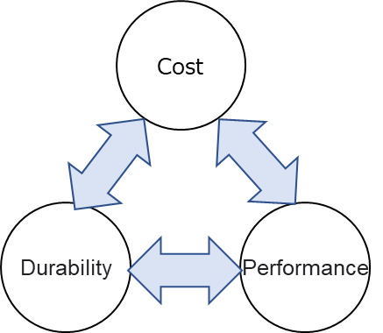

For example, by modifying high-compression pistons, cams, or intake and exhaust systems, you might gain performance in the form of peak power, but the trade-off is cost in the short term and durability in the long term perspective.

This document will show you how to adjust fuel and ignition timing, but there is a risk of loss of performance and durability when doing so. Try at your own risk.

## Before starting the adjustment

If the hardware is not working properly in the first place, the tweaks made to adjust it will have no or little effect.

The main checkpoints are as follows

* Correct operation of various sensors
* No leaks in supply and exhaust pipes
* No abnormality in the ignition system
* No difference in compression pressure between cylinders
* No difference in injector injection volume
* The two cylinders must be properly synchronized.

If the motorcycle has a high mileage, first check the condition of the hardware by referring to the service manual or Haynes manual, and repair or adjust as necessary.

For injectors, I recommend requesting an overhaul from a vendor who can obtain a report.

In many cases, this is all that is needed to improve the condition of the motorcycle. There is no need to read further.

How to detect hardware failures with software is presented on the following pages and beyond.

# Stock ECU Operation

Before starting the adjustment, it is necessary to know the specifications of the stock ECU, especially those related to fuel adjustment. If you start without knowing these specifications, you may not get the correct effect of the fuel adjustment.

The information in this section is an overview. For more information, please refer to the following links

<https://www.zeebulon.de/Mot/BMW_R1100GS_Tuning.htm>

If you understand the specifications, skip this section.

## Inputs and Outputs

The stock ECU has the following inputs and outputs and uses specific logic to change the outputs based on the input information in order to control the engine.

**ECU input value**

* number of rotations
* Accelerator opening (throttle position)
* atmospheric pressure
* Air temperature of air cleaner box
* oil temperature
* 02 Sensor
* Voltage

**ECU output value**

* Fuel injection amount (hours)
* Ignition timing (angle)
* Ignition residence time (angle)

For example, when the RPM is above 2000 RPM and the accelerator pedal position is 0 continuously, the ECU will set the fuel injection to 0. This is to save fuel.

## Feedback function

The stock ECU has the ability to feed back the O2 sensor's air-fuel ratio to the fuel injection rate under certain engine utilization conditions. This feedback has two states.

**(1) Closed loop**

Short-term feedback ON; **adjusts fuel injection to maintain an air/fuel ratio of 14.7 at a** specific RPM and gas pedal opening. Closed loop range is not clear. As a trend, a high percentage of cases fall under 4000 rpm, accelerator opening of 1/2 or less, and small gas pedal change. It is believed to have been set to optimize emission control driving tests.

**(2) Open loop**

Long-term feedback ON. area other than "(1)". Based on the pre-set fuel map, the result adjusted (learned) in "(1)" is applied for a long period of time. This area is considered to have been set with maximum consideration of driving characteristics, regardless of exhaust emission regulations.

In fact, when the LC-2, described below, is used to measure the air-fuel ratio, the graph below shows that in the closed-loop region, the air-fuel ratio remains at 14.7, as shown below, while in the open-loop region, the air-fuel ratio moves up and down.

*The following diagram shows a constant gas pedal opening speed for the sake of abstraction and ease of understanding. In reality, the air-fuel ratio varies depending on the speed at which the throttle is opened and the rpm. The same applies to the figures that follow.

This is a logical and efficient mechanism to compensate for changes in intake air volume due to individual differences and age-related deterioration (e.g., clogged air cleaners, cracked insulators) while meeting emission regulations.

The ECU also adjusts the air-fuel ratio when the intake and exhaust systems are changed to aftermarket parts or when the fuel pressure regulator or injectors are used to increase the amount of fuel.

This is an excellent feature for maintaining condition, but it can also be tricky when making engine adjustments.

## A/F sensor specifications

Since the stock is equipped with a narrow band O2 sensor, it outputs only the following three statuses based on the theoretical AFR of 14.7. This is because a wide-band sensor is expensive and because a narrow-band sensor is sufficient for the catalyst to work efficiently.

* rich
* Just (A/F ratio 14.7)
* lean

For example, when the actual A/F ratio is 13.0, the stock ECU knows that it is richer than the A/F ratio of 14.7, but does not know the difference from the A/F ratio of 12.0.

## Stock ECU Issues

The first is that the target AFR to be controlled in the closed loop region is fixed at 14.7. The problems with being lean have already been mentioned.

Second, the closed-loop tuning study results are stored in memory and affect the entire fuel system as long-term coefficients.

Although the motronic is reset by battery disconnection and relay removal, in some cases people perceive the change as an adjustment. This is the reason why I strongly recommend that the condition be monitored by data.

Third, the specifications of the stock ECUs are not publicly available, and the logic of fuel adjustment is not fully understood.

In this and subsequent sections, I will explain how to adjust the fuel, but there are advantages and disadvantages due to the fact that the logic is only speculative and may not be a complete solution to the problem.

As long as stock ECUs are used, it is difficult to change the control logic and compromises must be made.

If you want to eliminate all compromises, you should consider implementing an open source full control ECU. (Although it will take an enormous amount of work!)

The author is very interested in Speeduino. I would like to implement dual 02 sensors and a knock sensor.

Can someone please try it and publish the results?

<https://speeduino.com/shop/>

## Aftermarket parts issues

Control of the air-fuel ratio by closed loop overrides all inputs, including the ECU's fuel map; aftermarket parts that vary the ECU's map or sensor acquisition and adjust the fuel supply have no effect in the closed loop region and affect long-term feedback in the open loop region.

# Understand the current status of the engine

Before embarking on an engine adjustment, you should first have a correct data picture of the current condition of the motorcycle. Then, compare the data before and after the adjustment.

I do not deny that I rely on our senses, but in many cases the acquisition and adjustment of the senses themselves takes time. People tend to perceive the state of the machine incorrectly depending on their physical condition and mood.

There are two tools that should be implemented. (If you have an alternative solution, please let me know!)

If you stumble here, I do not recommend proceeding to the subsequent "adjustments". This is because you can only measure by feel whether the result of the adjustment has been reflected correctly. Worst case scenario, you will break the motorcycle.

I do not explain how to obtain and use the tools, so please search for them on the Web.

## Tool 1: GS911

It can be connected to the diagnostic plug of a BMW motorcycle to obtain fault codes and real-time data handled by the ECU and recorded on a PC. There are several ways to obtain and use the software, please search on the web or other sources.

First, it is worthwhile just to check the error codes to see if there are any hardware failures, such as sensors.

Typical real-time data that can be obtained include

* Injector injection time
* Ignition advance angle / Ignition dwell time
* Engine RPM
* throttle position
* Various sensor values (narrow range air-fuel ratio, oil temperature, intake air temperature, atmospheric pressure, voltage)

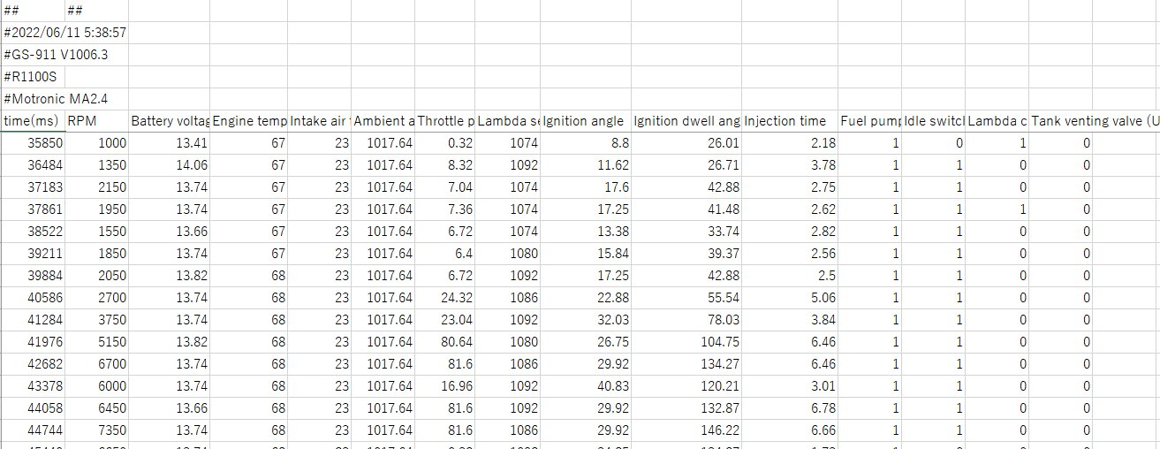

## Tool 2: innovate LC-2

Logger with wide band A/F sensor. It records the air-fuel ratio every ____ seconds to a PC. Installation instructions are provided in the APPENDIX for general-purpose products.

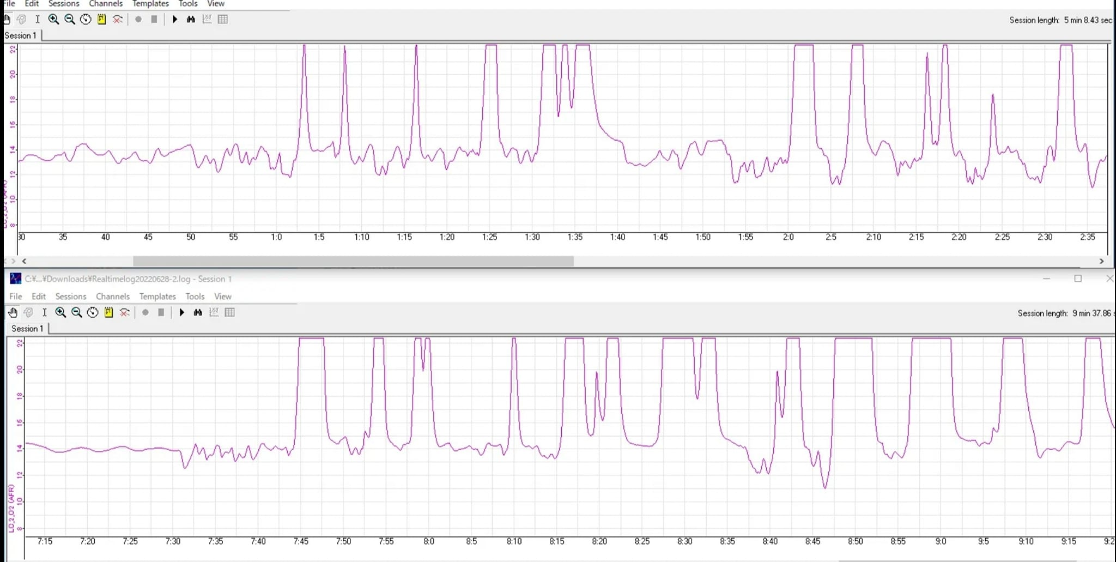In addition, there is an important function to adjust the overall air-fuel ratio. It will be explained in a later section.

## Familiarize yourself with the data

After installing the two tools, first run around in stock conditions and try logging under various conditions.

A small Windows 10 PC or tablet device and a tank bag are recommended.

The data acquired at this time will be useful as a comparison target for later tuning.

It is also helpful to stockpile prior knowledge on the web to better understand the relevance of the data to the event you wish to adjust.

Items to be understood include

* What is the proper air-fuel ratio?
* Fuel control by ECU
* Effect of ignition timing change

Once you have some idea of what each number means, proceed with the adjustment.

Also, if you notice any signs of malfunction, repair it.

# Fuel Adjustment

## Air-fuel ratio adjustment by LC-2

The LC-2 method of adjusting the air-fuel ratio is simple. The targeted A/F ratio is applied to the closed loop region, and then the adjusted (learned) coefficient is applied to the open loop.

### Operation Summary

The LC-2 has the ability to (easily) program the A/F ratio it reads and output an analog voltage.

Below is a stock and an overview of how the LC-2 works. For example, if the LC-2 is programmed with a target AFR of 13.7, the LC-2 compares the AFR of the wideband 02 sensor to the target value and outputs a rich, just, or lean voltage to the ECU The ECU receives the voltage and in a closed loop adjusts the fuel to the target AFR.

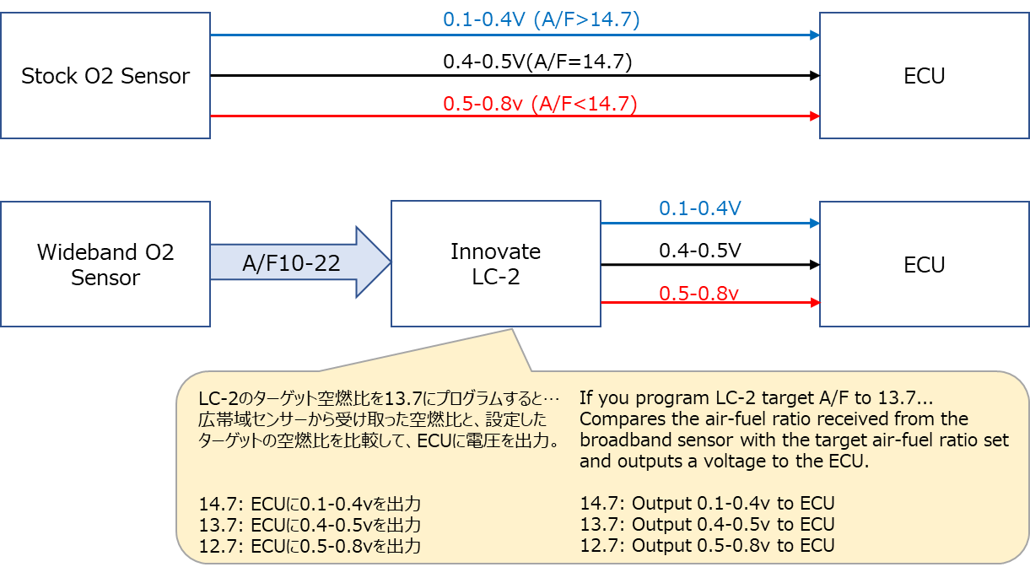

### Demerit

The open loop region may deviate from the ideal map because it reflects the result of adjustments made by the ECU in the closed loop. Below is an example of a graph for LC-2 with a target AFR of 13.7; the ECU's feedback function makes the open loop portion richer.

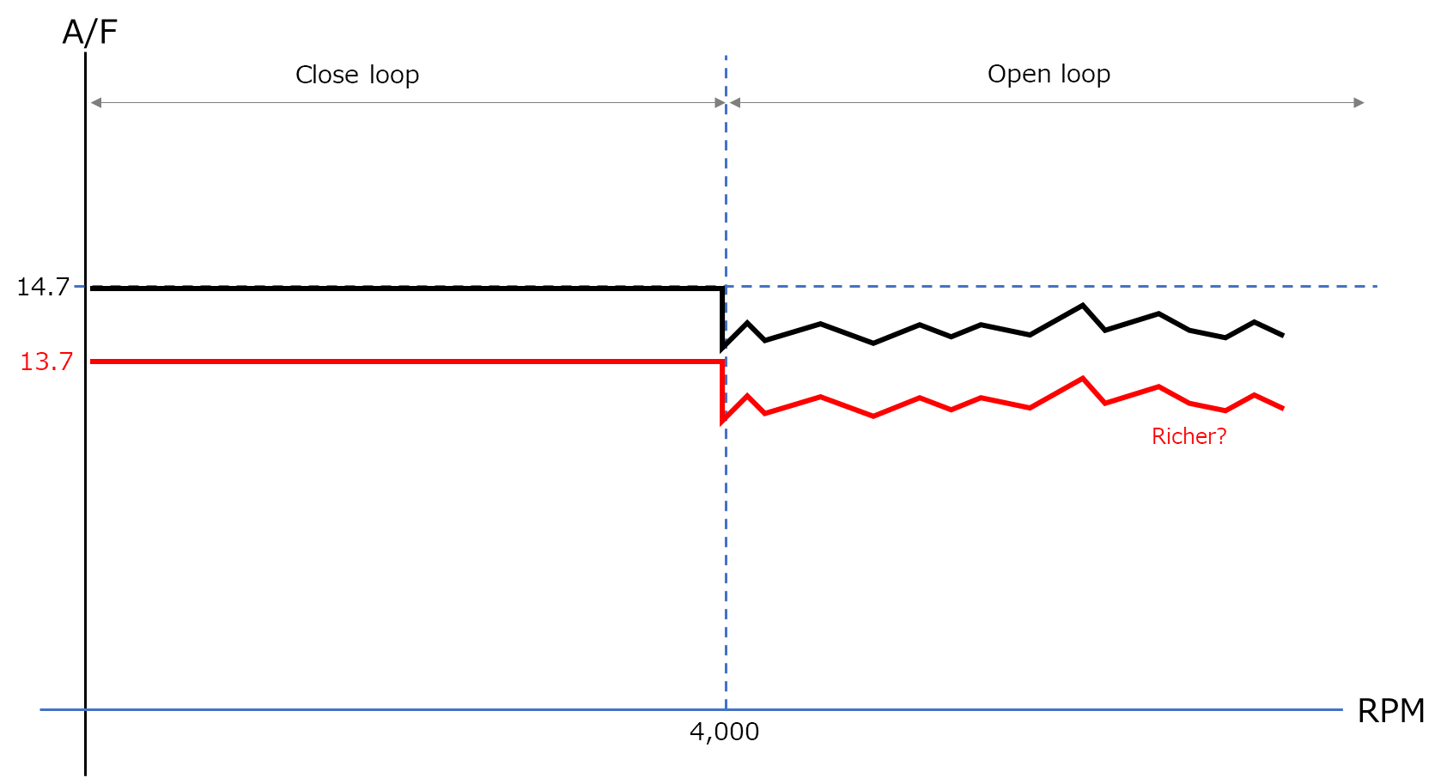

## ECU chip replacement

### Operation Summary

The R1100S ECU (Motronic 2.4) contains a replaceable chip (EPROM) that contains a fuel injection map and ignition advance angle map. This chip can be removed, the files imported to a PC, edited, and then written to a new chip, which can then be installed in the ECU.

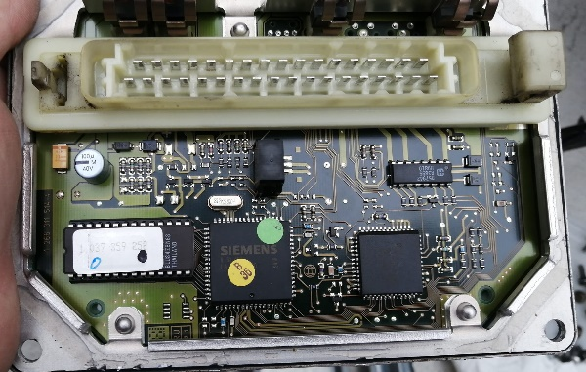

### What to prepare

Assuming that you have all the tools for general motorcycle maintenance, here is what you need to prepare

I will not explain how to obtain or use this service.

* Windows 10 PC
* 27c512 compatible chip *
* TL866ii Plus (ROM writer) *
* ECM Titanium 1.61 (ECU data editing software)
* Security Torx 0mm: for motronic disassembly

*Note: Motronic 2.4 from 1997 to 2001 uses a custom-made chip called **87c510** manufactured by Texas Instrument (TMS), and it is **difficult to obtain a blank chip that can be written to**, other than obtaining the ECU itself**.** Please refer to the following web site to identify your motorcycle model and chip.

<https://rtcsport.com/lisado-de-ecus>

* Adjustments can also be made by obtaining the following, but with the risk of rewriting the ROM of the stock.
* ERPROM Eraser
* PRG-1111 GQ-4X V4 + ADP-063 (instead of TL866ii Plus)

The author has created an adapter to convert 87c510 to 27c512.

Appendix 5 describes how to obtain the adapter.

### Chip Replacement Procedure

1. Remove the tip from the motronic.
2. Connect a ROM writer to the PC and read the file from the chip.
3. Edit the fuel injection data in the file using ECU editing software.
4. (For 87c510, erase stock ROM with eraser)
5. Write the edited file to a new chip.
6. Install a new tip on the motronic.

Please refer to the following video for chip removal and installation.

<https://www.youtube.com/watch?v=r3WOT2zC_qw>

*Motronic is sensitive to the state of grounding and settings, so cleaning the contacts and checking the state of grounding is recommended.

### demerit

Replacing the chip does not change the feedback logic. In other words, it will only have an effect on the open loop region, while the closed loop region will remain lean. Even if the intake and exhaust systems are customized and fuel is added with injectors, fuel pressure regulators, or other hardware, the overall lean or rich is adjusted by closed-loop learning, so the effect of replacing the chip is not significant.

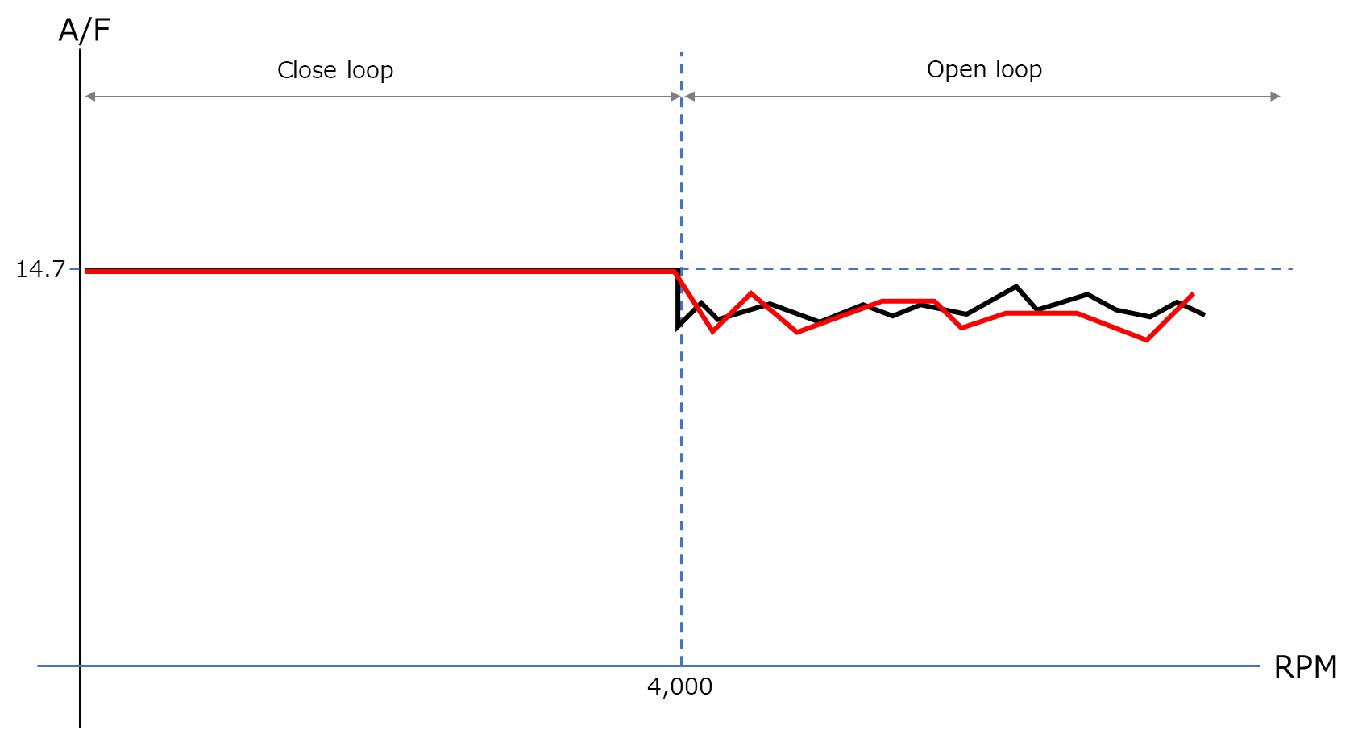

## ECU chip replacement + 02 sensor disconnection

### Operation Summary

In addition to replacing the ECU chip in 4.3, remove the 02 sensor.

This operation disables the closed-loop feedback function.

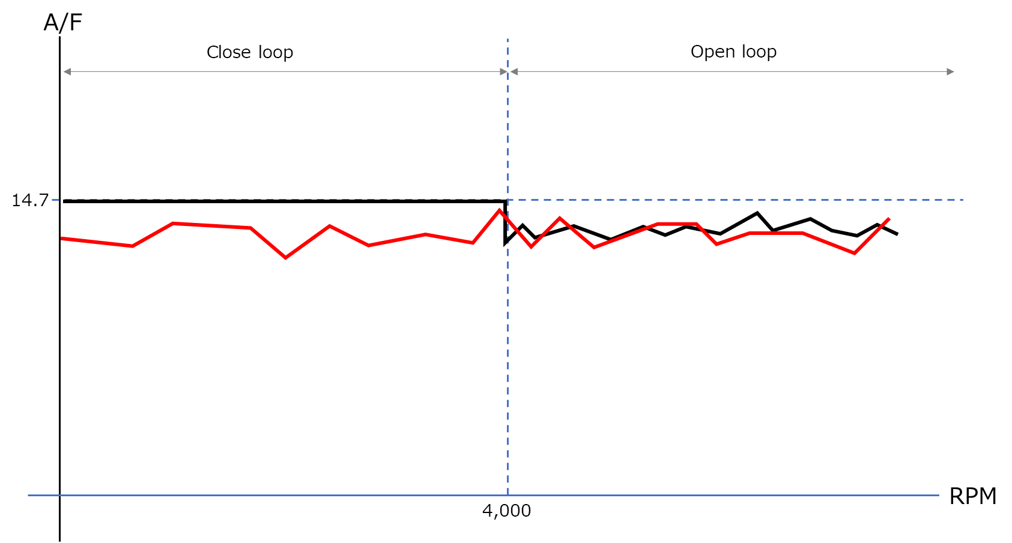

### demerit

At first glance, this may appear to allow freedom of adjustment, but flexibility is lost with respect to changes in engine conditions.

Whenever a hardware condition changes due to malfunction or other reasons, or when the intake/exhaust system is changed, the ECU chip settings must be changed to ensure that the proper air/fuel ratio is achieved.

It is time-consuming to replace (create) a chip for each change or adjustment.

Reference. To save time and effort in replacing chips, there are devices that can emulate the chip's operation and rewrite data in real time.

* Moates Ostrich2.0
* CobraRTP
* K-Special ERT

It also has a function to log which addresses on the chip are being accessed, except for (Ostrich 2.0), which is useful for map analysis.

However, as of July 2022, they all appear to be either discontinued or out of stock.

## LC-2 + ECU chip replacement

### Operation Summary

The LC-2 adjusts the closed-loop A/F ratio, and the ECU chip replacement adjusts the open-loop A/F ratio.

In the example in the figure, the LC-2 thickens the closed loop by 8% and the ECU chip thins the open loop A/F ratio by 8%.

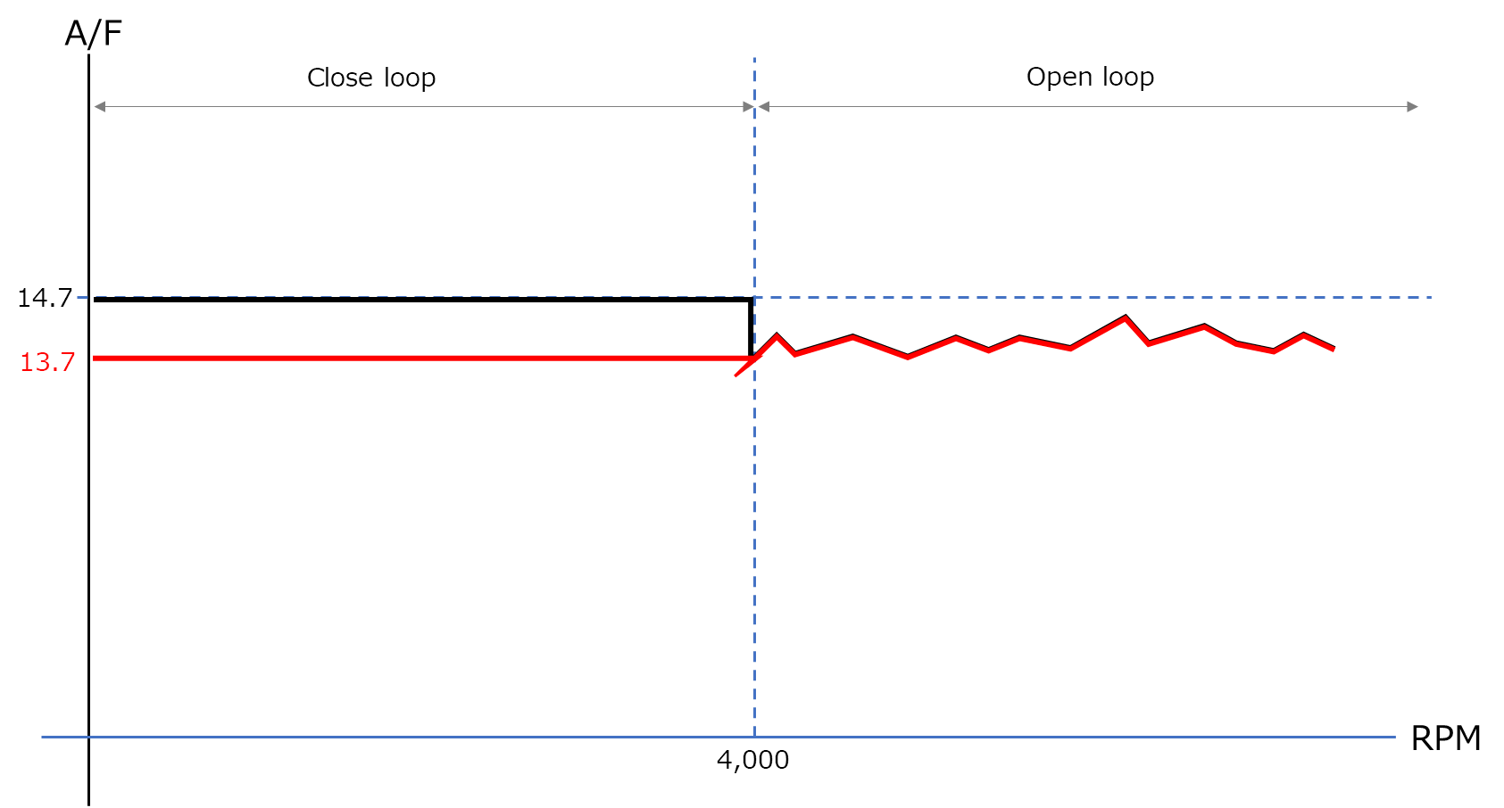

### demerit

The problem with this configuration is that it is difficult to predict the effect of changing the open loop setting, and it is hard to know whether the effect is properly reflected. This is because the extent of the open loop is not disclosed as a specification and has not been clarified.

For example, a narrow guess of the range of the open loop leaves a partially rich region, while a wide guess of the range of the open loop could lead to a closed loop range, which would cost feedback and also affect the entire open loop.

# Ignition timing adjustment

## summary

Stock ignition timing takes into account the quality of fuel by region and a safety margin. If higher octane fuel is available, there is room to increase fuel economy and torque by advancing the ignition timing.

## Ignition timing change by ECU chip replacement

Follow the same procedure as in "**4.3 Fuel Adjustment by ECU Chip Replacement**" to rewrite the ignition timing map instead of the fuel map.

## Ignition timing change by Hall sensor adjustment

You can advance or retard the angle by about 3 degrees by shifting the Hall sensor using some of the following procedures.

<http://users.rcn.com/dehager/service/oilhead_hall_sensors.pdf>

## demerit

Ignition timing has no systematic feedback function.

In other words, the appropriate degree of advance is a matter of guesswork. The avoidance of knocking or other obstacles that could result from an accidental excessive angle of advance is left to the rider's sensory perception.

Incidentally, the latest cars and motorcycles use sensors to detect knock and adjust the angle of advance, so the default setting has a reduced margin.

# Confirmation of adjustment results

## summary

To verify the results of your adjustments, actually log them on the motorcycle. This section presents the simplest method.

In some cases, different output data should be combined to see the results from different perspectives, and furthermore, sensors, loggers, etc. should be added to predict the next step in the adjustment process.

## Check the fuel condition

It is efficient to log and graph the data with the LC-2 and GS911.

After graphing, check to see if the target air/fuel ratio is reached at a specific RPM and gas pedal opening.

Below are the logs for the LC-2 and GSS911 when running with the LC-2 set to the target AFR of 15.0 The logs for the GS911 are graphed in EXCEL. It can be seen that the ratio remains at 15.0 in areas where gas pedal opening is low, and is around 13.0 in areas where RPM is high and the accelerator is opened rapidly.

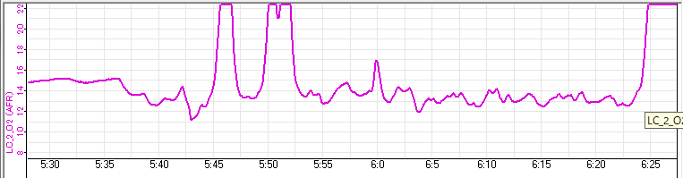

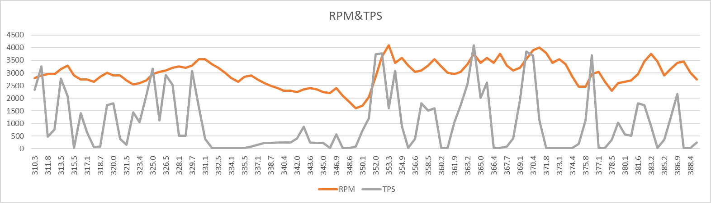

This example is not exact because it is only checking for rough deviations in the air-fuel ratio. There is a discrepancy in the time when the log is turned on. Also note that the TPS is multiplied by 100 for visualization purposes.

For even more rigor, the A/F log can be output as text, merged with the GS911 log, and output on the same graph. In this case, the LC-2 and GS911 logs can be turned on before starting the engine to determine the time to match.

## Check ignition timing

### Check Hall sensor adjustment

*Confirmation is in progress.

### Check ECU adjustment

Check the GS911 log to see if the set advance angle is applied at a specific RPM and gas pedal opening.

Below is the actual GS911 log.

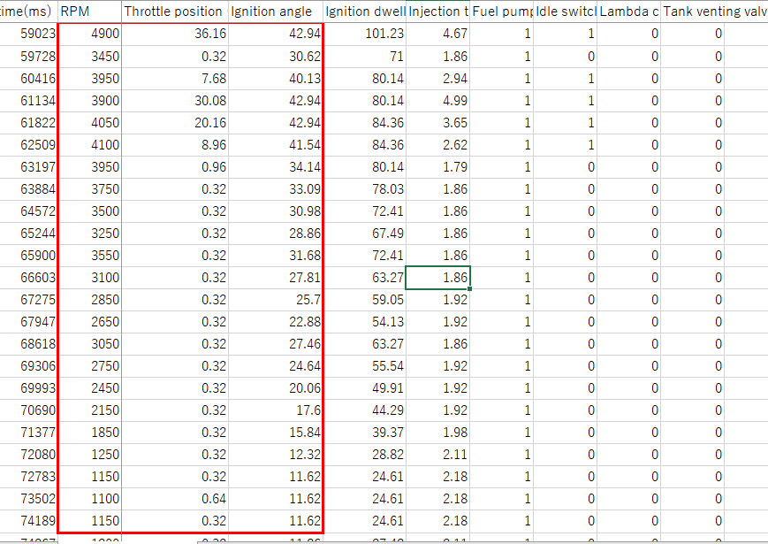

# Appendix

## Appendix 1 Installation of Innovate LC-2

### rough sketch

Below is an overview diagram.

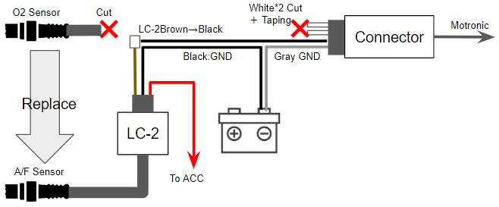

LC-2 is a general-purpose product that includes cars, so it is available in multiple cable lengths. For motorcycles, I recommend the 3-feet model. Even then, it is long, so pack it down if it bothers you; if you are not omitting ABS, you may have a hard time finding a place to install it.

Also, 12v is coming to either end of the white cable of the 02 sensor, but this is linked to the fuel pump, so it will be difficult to operate the calibration function of the LC-2 if it is connected.

### Reference program: A/F ratio set to target 13.2

Below is the LC-2 programmer with the lambda value set to 0.9 (about 13.2 AFR).

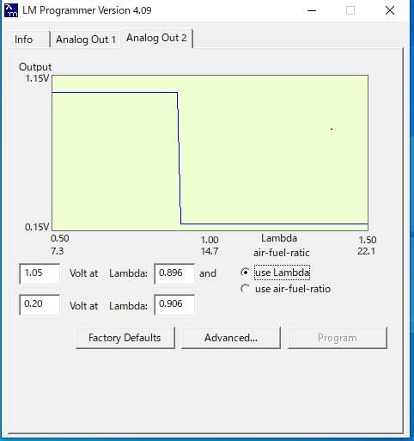

Assuming the above configuration diagram, please edit Analog2; the default setting values for LC-2 are also helpful.

## Appendix 2 Reference: Author's adjustments

The author is riding a 1998 R1100S. Hardware differences from stock are as follows

* Fuel pressure regulator: 3.0Bar -> 3.5Bar, using stock 1200RS
* Injectors: EV6 → EV14 1200RS stock injectors are used, adapter is outsourced
* Plugs: Scriminger Engine Developments pre-chambered plugs

The objective is to improve fuel economy and transient characteristics by increasing combustion efficiency.

I love horsepower, but I don't think it is what I want from the R1100S.

The fuel pressure regulator and injector changes should make it 15% richer, but because of the feedback function of the ECU, **software control to make it leaner is not necessary**. The figure shows data after 10 minutes of driving with the target AFR set to 14.0 in LC-2 and the ECU reset, but the AFR is maintained around 14.0 due to the long-term feedback.

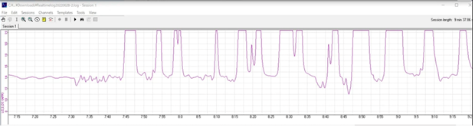

The author lives in Japan and the quality of gasoline is reasonably high, with an octane rating of 98 or higher.

Taking into account the adjustment of the above hardware differences and the good quality of gasoline, the following three maps are switched to reduce the margins. All the "0%" is the stock ratio.

### normal mode

The mode is selected in case of any malfunction or when low-octane fuel is used.

Fuel is set 15% leaner throughout the entire range due to hardware enrichment

Normal ignition timing

### Sharpe mode

* A mode that squeezes fuel to improve fuel economy and aims for a faster RPM increase.
* Target air-fuel ratio for LC-2 set at 15.0
* Set at 15% leaner across the board, minus hardware fuel increment
* High RPM high load region is set 5% thinner.
* At 2000 rpm or more, the ignition timing is advanced by 2 to 5 degrees.
* Achieved about 5% improvement in fuel economy compared to normal

### power mode

* A mode that adds torque to the Sharp mode for the purpose of increasing power.
* Target air-fuel ratio for LC-2 set at 14.0
* Set at 15% leaner across the board, minus hardware fuel increment
* High RPM high load range is set 5%-10% thinner.
* At 2000 rpm or more, the ignition timing is advanced by 2 to 7 degrees.
* Power increase of 5% or more compared to stock.

The reason for 15% lean in all three modes is to reduce the time for the ECU to learn about the 15% hardware fuel increment.

In addition, even in power mode, I do not feel any increase in power compared to stock. I know from my experience in setting up for races that you can never rely on your senses. If I had to say something, I would say that it makes me feel better, and I feel that the motorcycle is in better shape.

## Appendix 3: Simple horsepower measuring instrument

This section is still under construction and is therefore referred to as the Appendix. It will be promoted to this section as soon as the data is obtained.

Measurements with a dyno machine can only be taken at full throttle. Since the operating characteristics also require the measurement of transient horsepower and torque, I have prepared a formula to measure transient horsepower from the rpm of the GS911. Please copy and use it.

<https://docs.google.com/spreadsheets/d/1LOpvSk_DcZD82pQqnYvhSfly-UHCEh8s/edit?usp=sharing&ouid=101420970167778273283&rtpof=true&sd=true>

The minimum parameters to be entered are

* Measurement start speed
* Measurement end speed
* Measurement Time
* vehicle weight

Nevertheless, the GS911 cannot log gears, so speed cannot be calculated on its own.

On a separate sheet, I have placed a formula to calculate the speed from the tire circumference diameter and gear.

It may be better to record the speed with a separate GPS logger or other device and enter the speed.

It would be interesting to know the efficiency of the engine by mapping it to the fuel injection rate of the GS911 to get the horsepower/consumption per unit time.

## Appendix 4 Switching Maps by Coding Plug

This section is still under construction and is therefore referred to as the Appendix. It will be promoted to this section as soon as the data is obtained.

### What is a Coding Plug?

Coding plugs are simply jumper wires; the ECU determines which wires are connected.

The ECU has several fuel maps, which the ECU selects upon startup by checking the continuity of the coding plugs.

In the case of the R1100S, there are eight fuel maps and eight ignition timing maps on the stock chip. Six of these maps are for different regions of the world, and two are presumably for failure mode. Since there is little difference in the characteristics of the regional maps of the stock chip, only the coding plug does not change the characteristics significantly.

The data file of the ECU's chip also has a text map descriptor, and the result of switching can be determined by GS911.

Below is the map descriptor for the R1100S.

### Coding plug specifications

Please refer to the following forum for R1150 coding plug data.

<https://forums.bmwmoa.org/showthread.php?58495-Coding-Plugs-R1100-R1150-Decoded>

Information on coding plugs for the 1998 R1100S is as follows

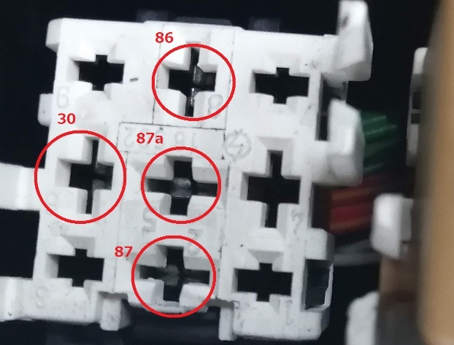

|  |  |  |
| --- | --- | --- |
| Connection | Map Descripter | Map Number |
| 30-86 | R1100S CH-Kat | 5 |
| 30-87a | R1100S ECE Nmax | 3 |
| No-Plug,Etc | R1100S ECE-Kat | 1 |

I have tried patterns with two or three cables, but it will be one of these three.

I have information that the 2002 and later twin spark R1100S has another map choice of 30-86-87. I have not tried it.

### Map Switching by Coding Plug

If you devise a switch or other means to switch the coding plug, you can switch the map in the chip.

However, the ignition switch must be turned OFF/ON for switching.

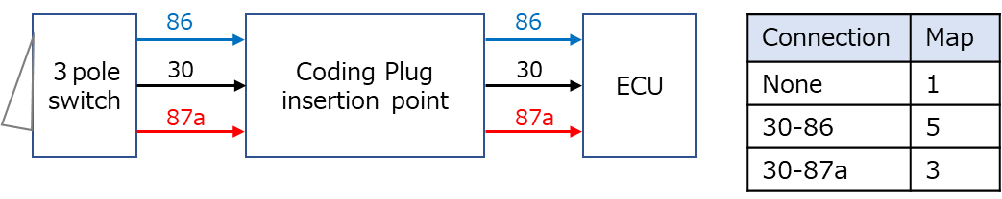

## Appendix 5 87c510 to 27C512 adapter

Since the 87c510 chip is not commercially available, it is necessary to obtain an adapter that can use the easily available 27c512 chip.

This adapter was commercially available at one time, but is now obsolete and must be commissioned from a board manufacturer.

The data and files required to place an order are compiled below.

<https://drive.google.com/drive/folders/1TjKBreAP3PcyNmIQKFCrxLElePlc1LsI?usp=sharing>

The author procured it from the following site for less than $120. (including $30 for shipping to Japan)

<https://www.pcbgogo.com/>

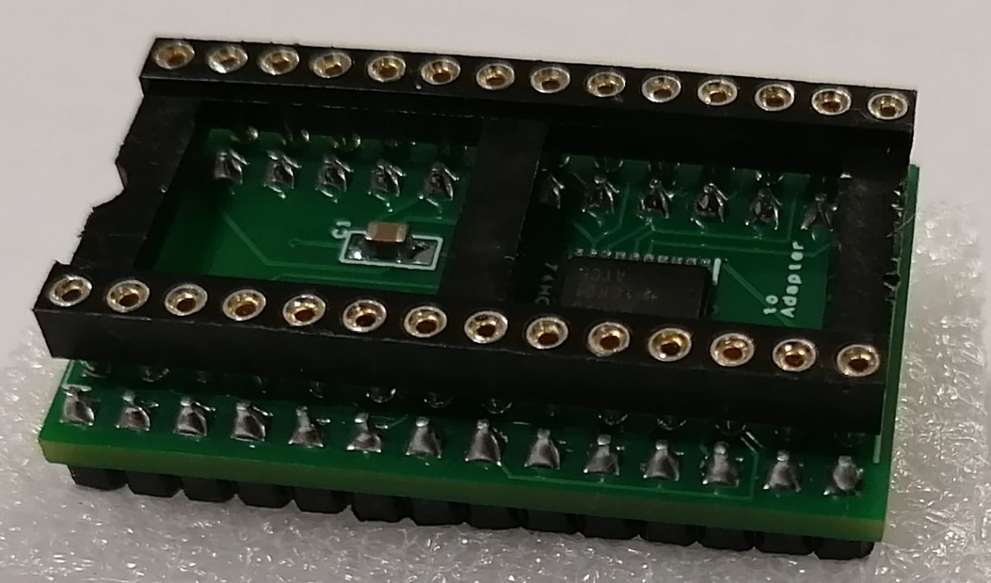

## Appendix 6 Contact information for the author

Author's contact information. Not all contacts may be answered.

<https://www.facebook.com/yosuke.tanaka.169>

[y3tanaka@gmail.com](mailto:y3tanaka@gmail.com)

I will not respond to questions that can be looked up on the web.

**career**

* IT consultant/engineer with little to do with electronics
* Japanese Motorcycle Gymkhana Class A
* Motorcycle Motocross National Class A
* There was a time when I held the course record on the mini bike course....
* I have enough wrenching skills to disassemble and reassemble a whole motorcycle.

*Not necessarily in better shape.

* With two small children, I have stopped racing and now ride motorcycles mainly for touring.

